# Advance Excel Assignment 5

# 1. How many types of conditions are available in conditional formatting on Excel?

There are 5 types of conditional formatting visualizations available:

* Background Color Shading (of cells)
* Foreground Color Shading (of fonts)
* Data Bars
* Icons (which have 4 different image types)
* Values

# 2. How to insert border in Excel with Format Cells dialog?

On a worksheet, [select the cell or range of cells](https://support.microsoft.com/en-us/office/select-cell-contents-in-excel-23f64223-2b6b-453a-8688-248355f10fa9) that you want to add a border to, change the border style on, or remove a border from.

1. On the **Home** tab, in the **Font** group, do one of the following:
   * To apply a new or different border style, click the arrow next to **Borders** Button image, and then click a border style.

**Tip:**To apply a custom border style or a diagonal border, click **More Borders**. In the **Format Cells** dialog box, on the **Border** tab, under **Line** and **Color**, click the line style and color that you want. Under **Presets** and **Border**, click one or more buttons to indicate the border placement. Two diagonal border buttons Button image   Button image are available under **Border**.

1. To remove cell borders, click the arrow next to **Borders** Button image, and then click **No Border** Button image.

# 3.How to Format Numbers as Currency in Excel?

To quickly apply the Currency format, select the cell or range of cells that you want to format, and then press Ctrl+Shift+$.

# 4. What are the steps to format numbers in Excel with the Percent style?

To quickly apply percentage formatting to selected cells, click **Percent Style** Button image in the **Number** group on the **home** tab, or press **Ctrl+Shift+%**. If you want more control over the format, or you want to change other aspects of formatting for your selection, you can follow these steps.

1. On the **Home** tab, in the **Number** group, click the icon next to **Number** to display the **Format Cells** dialog box.

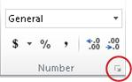

1. In the**Format Cells** dialog box, in the **Category** list, click **Percentage**.

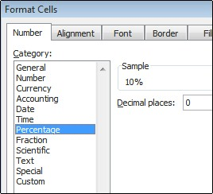

1. In the **Decimal places** box, enter the number of decimal places that you want to display. For example, if you want to see **10%** instead of **10.00%**, enter **0** in the **Decimal places** box.

# What is a shortcut to merge two or more cells in excel?

1. Select the cells to merge.
2. Select **Merge & Canter.**

# 6. How do you use text commands in Excel?

1.Left ()

You can use the Left function when you want to extract the leftmost characters from a string. Syntax **=left (text, num_char)**

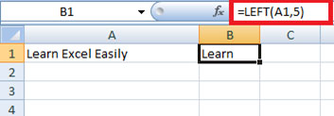

Similarly, you can also use the Right function to extract the rightmost characters from a string.

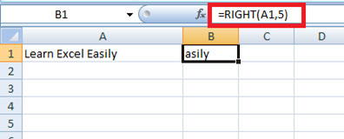

2.  Len ()

Len function in Excel helps you to know the length of a string that is number of characters in a string. Syntax **= LEN (text)**

**Note** – Spaces are included while calculating length.

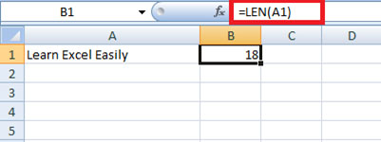

3.  Mid ()

Mid function in Excel is used to extract the characters from the middle of a string. Syntax **= MID (text, start_char, num_chars)**

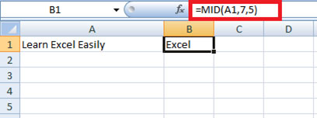

4.  Find ()

Find function in Excel is used when you want to know the position of certain characters in a particular string. Syntax **=FIND (find_text, within_text, [start_num])**

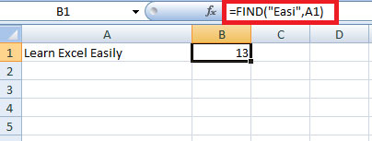

5.  Proper ()

The proper function in Excel capitalizes each word in the string, that is, it converts the case into proper case. Syntax **=PROPER(Text)**

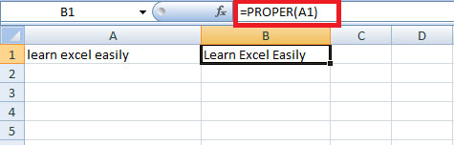

6.  Rept ()

Rept function in Excel is used when you want a certain text to be repeated a certain number of times. Syntax **=REPT (Text, number_times)**

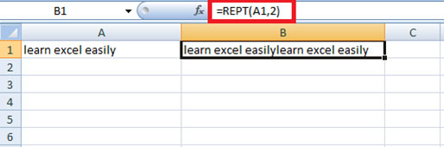

7. Trim ()

Trim function in Excel removes the unnecessary spaces from a particular string.  
Syntax **=TRIM (Text)**

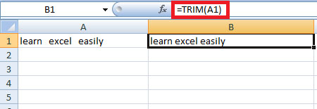

8.  Upper ()

Upper function in Excel converts the text into Upper case from lower case. Syntax **=UPPER (Text)**

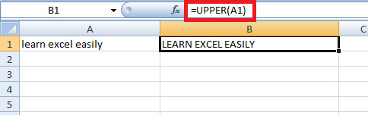

9.  Substitute ()

Substitute function in Excel helps to replace existing text with a new text in a particular string. Syntax **=SUBSTITUTE (text, old_text, new_text, instance number)**

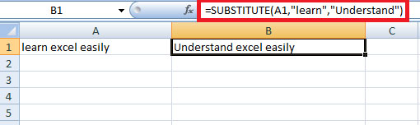

10.  Concatenate ()

The concatenate function in Excel helps to join the text of two or more cells. Syntax **=CONCATENATE (text1, text2….)**

